1. Ah Cheh Wantan Mee  
   Jalan Tun Tan Cheng Lock  
   GPS: N2 11.710 E102 14.815
2. [Melaka – Bert’s Garden @ Tanjung Kling](http://makantrip.com/2009/05/melaka-berts-garden-tanjung-kling/)

icon1Cupnoodles | icon2[Melaka (Malacca)](http://makantrip.com/category/food-guide/places-to-eat/melaka-malacca/), [Places to Eat](http://makantrip.com/category/food-guide/places-to-eat/) | icon405 8th, 2009**|**icon3[2 Comments »](http://makantrip.com/2009/05/melaka-berts-garden-tanjung-kling/#comments)

Bored of the same old Melaka scene at night? Well… I think Bert’s Garden provide a good alternative to that. Located in Tanjung Kling and away from all the hustle and bustle of Melaka town especially weekend traffic jams, this seems to be a nice place to chill out and chat the night away.

[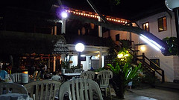](http://farm4.static.flickr.com/3603/3511983599_3f2b93d780.jpg)

[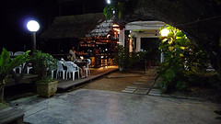](http://farm4.static.flickr.com/3382/3511986191_1a061c0b00.jpg)

[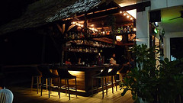](http://farm4.static.flickr.com/3350/3511983283_7aabe5be44.jpg)

[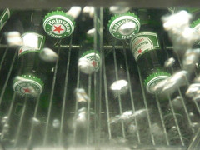](http://farm4.static.flickr.com/3570/3511986991_bf865dd5a3.jpg)

Its located quite far away from Melaka town itself near to Riveria Hotel this actually leads to the old road to go to Port Dickson from Melaka. Its quite hidden and quite easy to miss as the road is dark, so I hope the GPS helps.

Bert’s Garden is locate by the seaside with a nice little parking lot where you see a lot of locals trying their luck fishing there. Bert’s Garden is actually the garden of a colonial house which have been refurbished to be a restaurant cum beer garden kind of style.

There are plenty of seats by the seaside, but becareful of those in the hut, we had splashing sea water jumping up on us when the wave got stronger. The beer here goes for RM38++ per jug and we ordered some Commando Fries (RM10) which are french fries fried with peanuts, onions, anchovies, etc. very very nice!

[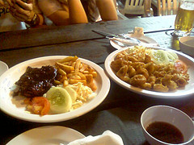](http://farm4.static.flickr.com/3617/3511982531_aa65b20602.jpg)

[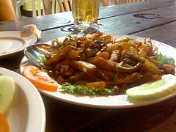](http://farm4.static.flickr.com/3639/3512787578_85d71091da.jpg)

The deep fried sotong is good too but at RM20 is really too costly and chicken chop with black pepper is yummy too but RM18. Food is a bit pricey to me but at least taste good.

But if you like a place with a nice and breezer environment with sound of waves sitting by the seaside, this could be your place ;).

**Bert’s Garden**  
2078-C Jalan Kg Pinang, Tanjung Kling, 76400 Melaka  
Tel: 06-3152213  
GPS: N2 13.212 E102 11.201

1. **Coconut House**  
   No.128 Jalan Tun Tan Cheng Lock, 75200 Melaka  
   Tel: 06-2829128  
   GPS: N2 11.794 E102 14.699
2. **Teow Chew** [**Bak Kut Teh**](http://en.wikipedia.org/wiki/Bak_kut_teh)**.**

Located in Jalan Melaka Raya 4, next to a big open air parking lot, locates Teow Chew [Bak Kut Teh](http://en.wikipedia.org/wiki/Bak_kut_teh).

GPS: N2 11.219 E102 15.245

# M[elaka Chicken Rice Balls](http://sixthseal.com/2009/06/melaka-chicken-rice-balls/)

[Chinese](http://sixthseal.com/category/chinese-14/), [Stalls](http://sixthseal.com/category/food-reviews/stalls/)[Add comments](http://sixthseal.com/2009/06/melaka-chicken-rice-balls/#respond)

Jun222009

[Share](http://www.facebook.com/sharer.php)

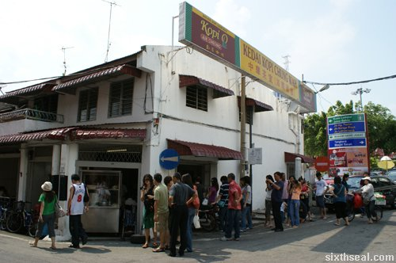

**Melaka**is famous for **chicken rice balls**. It’s practically an institution over there, with shops dedicated to the golf sized morsels of delight every few meters (or so it seems). There are a lot of established chicken rice ball shops in Melaka, with each person having their favorite. Jennifer brought us to **Chop Chung Wah**at **Jalan Hang Jebat**, off **Jonker Street**.

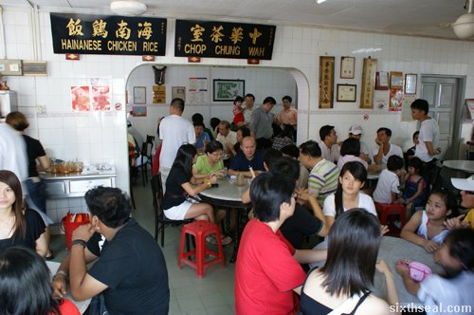

This place is arguably one of the best chicken rice ball shops in Melaka. The line snaking out of the shop is a testament to the popularity of the chicken rice balls. People actually waitunder the hot Melaka sun just to eat the chicken rice balls here. Don’t play play, got queue one this place.

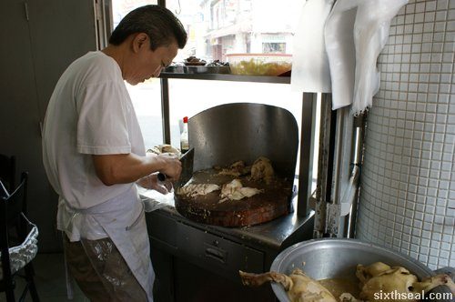

The interior of Chop Chung Wah is basic, with seating arrangements that harks back to the 60′s. Think marble tables and stools. It only registered to me while writing this that I could very well have fallen off the stool coz I usually sit on chairs. There are articles from newspapers adorning the walls and an interesting anecdote here is that the place got on The Star in 2006…and Jenn was part of the entourage who went for that food review.

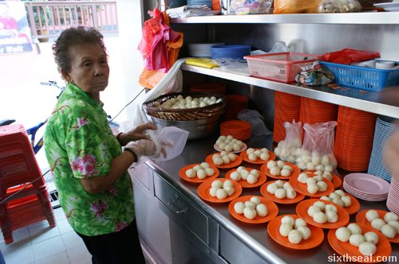

The chicken rice balls is hand rolled by an old lady, conveniently stacked five (5) to a plate in an endless stream to cater to the never-ending march of customers filing into the coffee shop. I’m amazed that they can cope with such demand at all – every single table is full, with people queuing up outside waiting to get in. It’s an exercise in efficiency, I tell you.

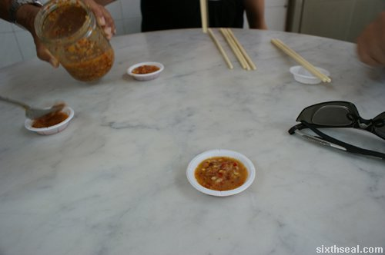

The chicken chopping is done by the son of the owner (who can be rather grumpy sometimes ;)). The family operating this place is Hainanese, and word is, the son is so busy with this chicken rice ball shop that his wife was literally shipped in from Hainan, China to help with the business. It’s a true Hainanese place, they take the phrase “keeping it within the family” to new heights.

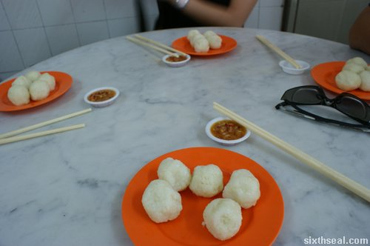

The chicken in Chop Chung Wah only comes in one variant – steamed chicken. It’s very authentic Hainanese chicken indeed. I found the meat juicy and tender, and you can even see the essence of chicken forming a bed for the steamed chicken. The key ingredient in chicken rice is the chilli, as most would tell you, and this place dishes up really good chilli sauce.

The chicken rice balls are actually flavored with chicken stock and have a slight glutinous texture to it. It goes down really well, and we ordered another plate coz five rice balls each is just not enough. Apparently, five rice balls is equivalent with a regular plate of chicken rice. It tastes delectable dipped in chilli sauce!

It’s definitely a must try if you haven’t eaten chicken rice balls in Melaka before. Just look for the awe-inspiring queue to find the place. :)